Project 17: Ultrasonic Following and Obstacle Avoidance

1. Description
The ultrasonic sensor uses sonar to determine distance to an object like bats do. It will emit the ultrasonic waves after trigger signals. When the ultrasonic waves encounter the object and are reflected back, the module will output an echo signal, thus, it can determine the distance of object from the time difference between trigger signal and echo signal.
As the picture shown, it is like two eyes. One is transmitting end, the other is receiving end.
In this project, we will learn ultrasonic ranging, ultrasonic following and ultrasonic obstacle avoidance.
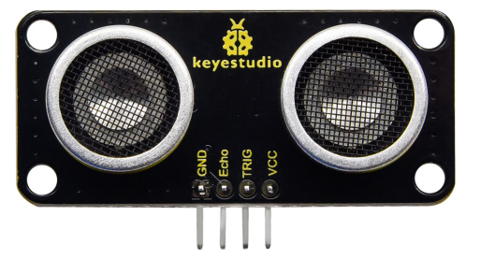

2. Specifications
- Working voltage：DC 3.3V-5V
- Working current：50mA－100mA，normally is 65mA
- Maximum power：0.5W
- Maximum detection distance：3m
- Blind spot：less than 4cm
- Sensing angle：less than 15 degrees
- Interface：4-pin interface of a spacing of 2.54mm
- Positioning hole ：3mm diameter
- Working temperature： -10℃ - +60℃
- Dimension：49mm*22mm*19mm
- Environmental protection attributes: ROHS

3. Working Principle
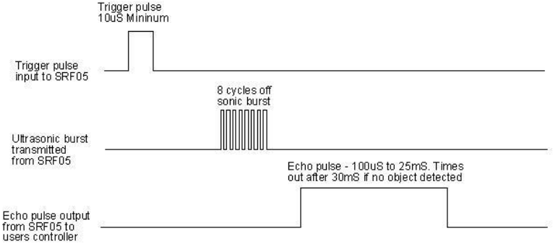
(1)Pull down TRIG then trigger high level signals with least 10us;
(2)After triggering, the module will automatically send eight 40KHz ultrasonic pulses and detect whether there is a signal return;
(3)If there is a signal return, when ECHO outputs a high level, then the duration of the high level is the time from transmission to reception of the ultrasonic waves. Then test distance = high level duration *340m/s*0.5.

4. Preparation
（1）Insert the micro: bit correctly into the expansion board
（2）Connect the battery holder to the expansion board
（3）Turn on the power switch（Slide the POWER switch to ON end）
（4）Connect the micro：bit and computer via a micro USB cable
（5）Open the Web version of Makecode
(6 ) Install the ultrasonic to the expansion board
If you want to add the Mini car extension library(you can refer to the "1. Development environment configuration "file).

5. Code for Ultrasonic Ranging
Upload the“code-1.py” file directly from the tutorial

Code 1:
from microbit import *
from keyes_MiniCar import *
minicar = MiniCar()
distance = 0

while True:
distance = minicar.get_distance() #Set minicar.get_distance() to distance
print("distance:", distance) #Print the distance
sleep(1000)

After downloading code, keep USB cable connected, click“REPL”button and press the reset button. REPL window shows the distance value between the ultrasonic sensor and the obstacle(as shown below):
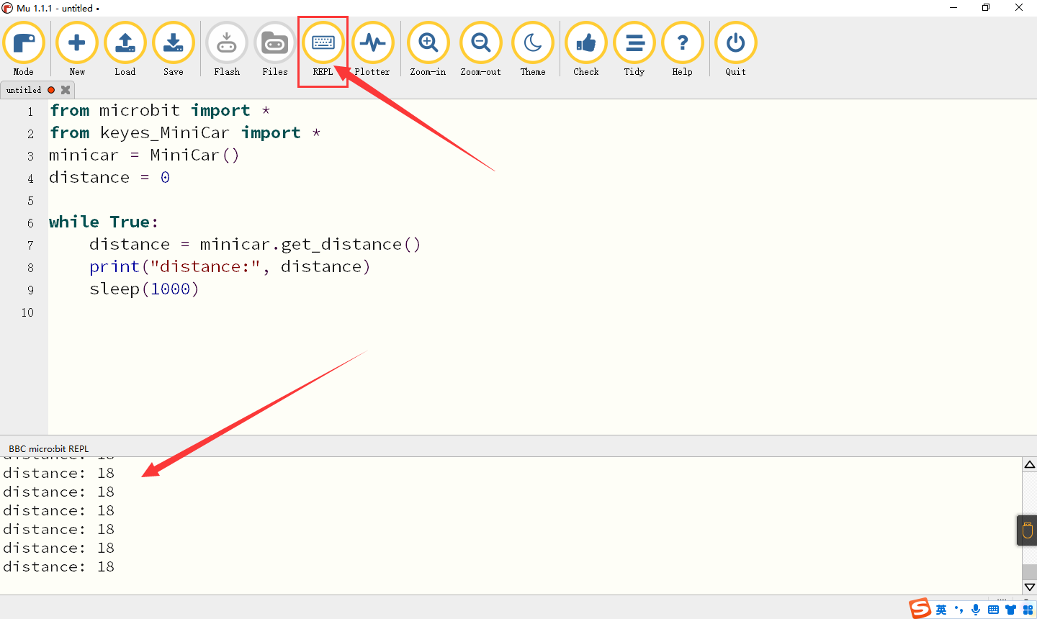

6. Flow Chart of Ultrasonic Following
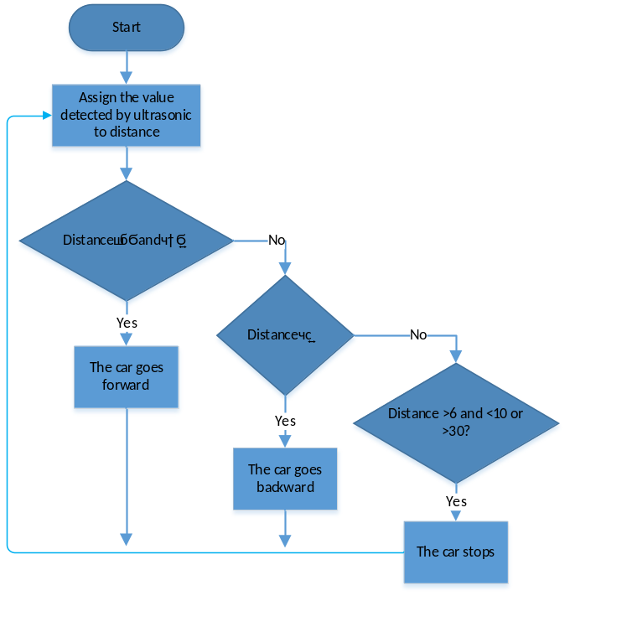

7. Code for Ultrasonic Following
Upload the“code-2.py” file directly from the tutorial
Code 2:
from microbit import *
from keyes_MiniCar import *
minicar = MiniCar()

while True:
distance = 0
distance = minicar.get_distance() #Set bitCar.get_distance() to distance
if distance >= 10 and distance <= 30: #Judge if 10≤ distance≤30
minicar.Motor_L(1, 100) #The car advance
minicar.Motor_R(1, 100)
sleep(50)
elif distance <= 6: #Judge if distance≤ 6
minicar.Motor_L(0, 100) #The car moves back
minicar.Motor_R(0, 100)
sleep(50)
elif (distance > 6 and distance < 10) or distance > 30: #Judge if 6<distance<10 or >30
minicar.Motor_stop() #The car stops
sleep(50)
Test Result:Upload the code and open the power switch on the car. If there is an obstacle in the place larger than 10cm and less than 30cm in front of the car, the car moves forward, if the obstacle appears within 6cm, the car will back up, and it stops when it is greater than 6cm and less than 10cm or greater than 30cm.

8. Flow Chart of Ultrasonic Obstacle Avoidance
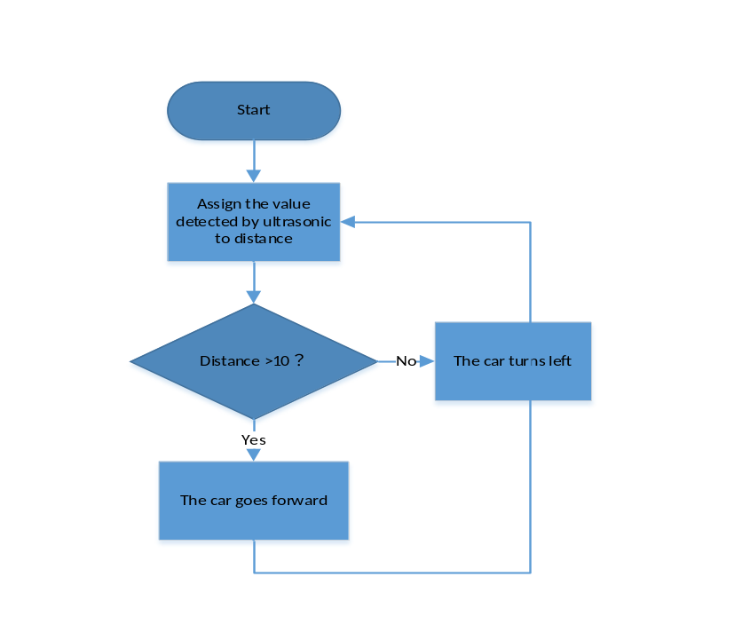

9. Code for Ultrasonic Obstacle Avoidance
Upload the“code-3.py” file directly from the tutorial
Code 3:
from microbit import *
from keyes_MiniCar import *
minicar = MiniCar()

while True:
distance = 0
distance = minicar.get_distance()
if distance > 10:
minicar.Motor_L(1, 70)
minicar.Motor_R(1, 70)
sleep(50)
else:
minicar.Motor_L(0, 70)
minicar.Motor_R(1, 70)
sleep(50)

Test Result: Upload the code and open the power switch on the car. If the distance is larger than 10cm, the car will go forward, if within 10cm, it will turn left.

